**exacqVision POS-ATM Information Guide**

*This document applies to exacqVision 4.3 and later.  
  
*Serial data can be received using RS-232, HTTP, or TCP/IP. The data must be in an **un-encrypted** ASCII format. Formatting such as .xml can be used, but the data cannot be parsed.  
  
*If there are questions the data format, see sections 4 and 5.  
  
  
**exacqVision Serial Data Capabilities**

1. Serial data is captured in a line-by-line format. This imposes the following limitations:  
     
   *Filtering cannot be done on a character basis.  
     
   *Filtering characters on a line will filter out the whole line.
2. It is preferable for each transaction type to have defined a Start of Transaction (SOT) and End of Transaction (EOT).  
     
   *If no SOT and EOT are defined, entering "VOID" in the search serial box on the search cameras page will return only the line in each transaction where the "VOID" occurs instead of the whole transaction.  
     
   *Characters defined as Line Feed, Form Feed, Carriage Return, and Vertical Tabulation cannot be used as the final character in an SOT, EOT, or mask.  
     
   *Each transaction must have a beginning and end even if no SOT or EOT is defined. This means that each transaction must have an end-of-line character such as those listed in 2b.
3. Event Key Words are not used for filtering. Key Words are used to trigger events defined in Event Linking.
4. Live Display and Record Masks will filter out data that matches the string. However, the rules in Step 1 still apply.
5. Character substitution is not available.

**Configuring exacqVision**

For information on how to setup the exacqVision system, open exacqVision Client. On the Serial Profile and Serial Ports pages, click on the Help button (or press F1).

**Capturing and Analyzing IP Serial Data**

Use Wireshark to verify a TCP/IP data stream for integration by completing the following steps:

1. Perform a Wireshark capture on the network for the data stream going to the POS/ATM device. For information on capturing traces, see the exacqVision Wireshark Quick Start Guide (sec. 2) at <https://www.exacq.com/kb/?kbid=18575>.
2. Filter the data in the Wireshark trace based on the IP of the device you are interested in. Here is sample data from a Wireshark capture:  
     
   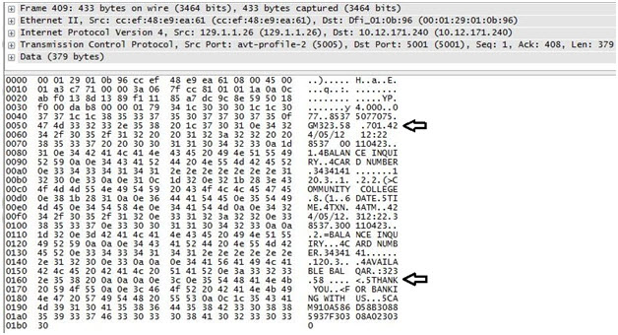
3. In this example, legible text is displayed. This means that the data is **un-encrypted**.
4. Look at the data and try to find areas that will work as an SOT and EOT. In the example shown, 701.42 (preceding the date) could be used to trigger the start of the transaction, and THANK YOU could be used to trigger the end of the transaction.

**Capturing and Analyzing RS-232 Serial Data**

The easiest way to analyze RS-232 serial data is to do the following:

1. Create a profile in exacqVision Client that does not contain an SOT or EOT.
2. Create a Serial Port with the proper settings to match the sending device.
3. Connect the RS-232 ports between the sending device and the exacqVision server.
4. In exacqVision Client Live View, drag the name of the Serial Port into the live view area.
5. Execute a transaction and watch exacqVision Client. If you see legible text on the screen, that means the data is un-encrypted and can be used for integration. The following image shows an example of un-encrypted data.  
     
     
     
   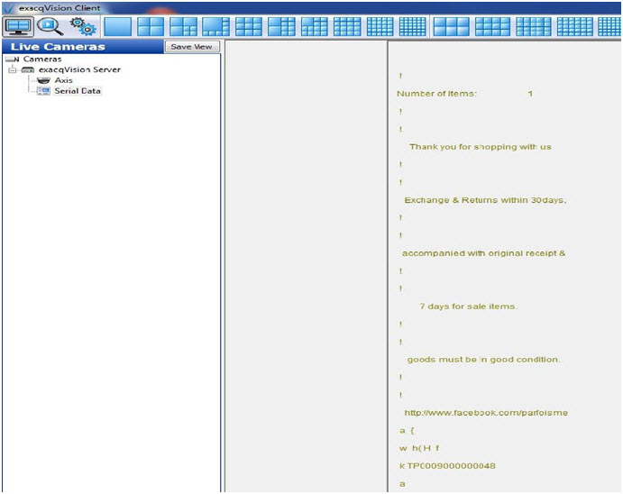

To capture RS-232 serial data to be analyzed later, complete the following steps:

1. Use a program such as Putty (<http://www.putty.org/>) to capture the data on the sending device.
2. Use a program such as Netcat (<http://netcat.sourceforge.net/>) to play back the file captured in step 1.
3. The steps to display the data in exacqVision Client are the same as steps 1-5 at the start of this section.